**D.SARATH BABU**

**EXP15.CREATE**

**A**

**SIMPLE**

**WEB**

**SITE**

**USING**

**ANY**

**PUBLIC**

**CLOUD**

**SERVICE**

**PROVIDER**

**(**

**AZURE/GCP/AWS**

**)**

**AND**

**CHECK**

**THE**

**PUBLIC**

**ACCESSIBILITY**

**OFTHE**

**STORED**

**FILE**

**TO**

**DEMONSTRATE STORAGE AS A SERVICE**

**AIM:**

CREATE

A

SIMPLE

WEB

SITE

USING

ANY

PUBLIC

CLOUD

SERVICE

PROVIDER

(

)

AZURE/GCP/AWS

AND

CHECK

THE PUBLIC

ACCESSIBILITY

OFTHE STORED FILE

TO DEMONSTRATE STORAGE

AS

A

SERVICE

**Procedure:**

**STEP1:**

FIRSTLY,

GO

TO

APPSERVICE

TO

CREATE

AN

WEBAPP.

**STEP2:**

ENTER

THE

RESOURCE

GROUP

AND

WEBAPP

NAME

AND

REGIONAND

SELECT

THE

LINUX OS.

**STEP3:**

AFTER

ENTER

THE

ALL

THE

NECESSARY

THINGS

CLICK

THEREVIEW

AND

CREATE

AND CLICK

THE CREATE

THE WEB

APP.

**IMPLEMENTATION:**

**STEP1:**

**FIRSTLY,**

**GO**

**TO**

**APPSERVICE**

**TO**

**CREATE**

**AN**

**WEBAPP.**

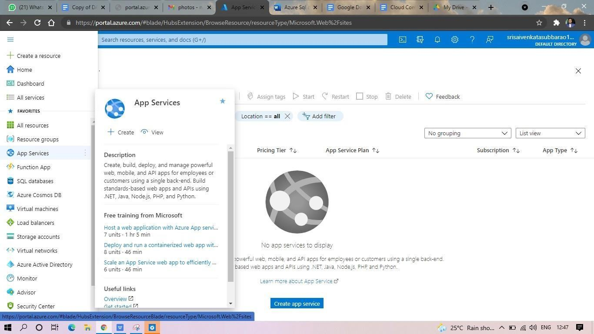

**STEP2:**

**ENTER**

**THE**

**RESOURCE**

**GROUP**

**AND**

**WEBAPP**

**NAME**

**AND**

**REGIONAND**

**SELECT**

**THE**

**LINUX OS.**

**STEP3:**

**AFTER**

**ENTER**

**THE**

**ALL**

**THE**

**NECESSARY**

**THINGS**

**CLICK**

**THEREVIEW**

**AND**

**CREATE**

**AND CLICK**

**THE CREATE**

**THE**

**WEB**

**APP.**

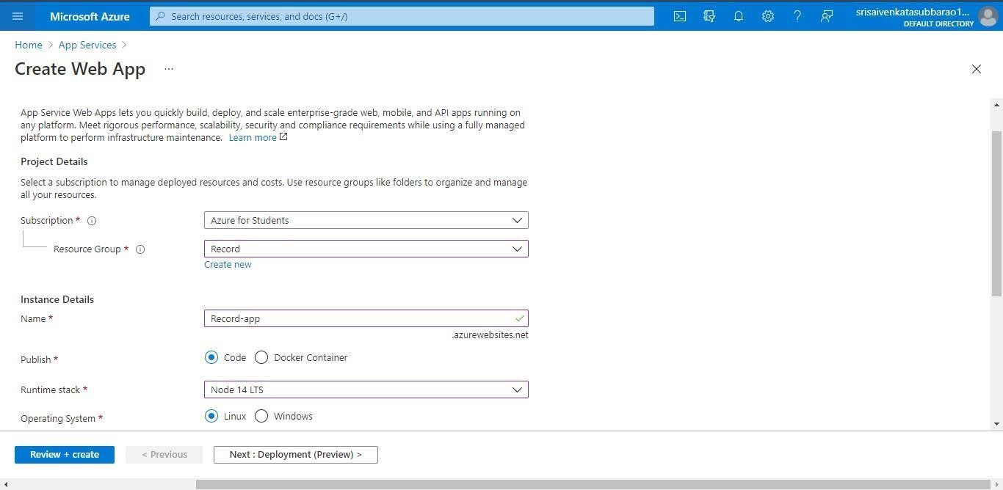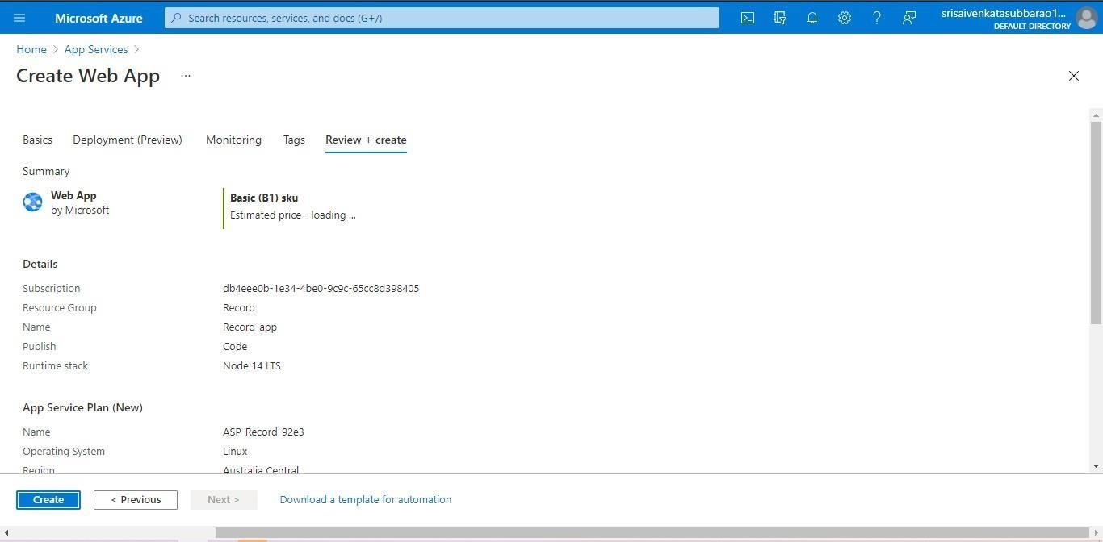

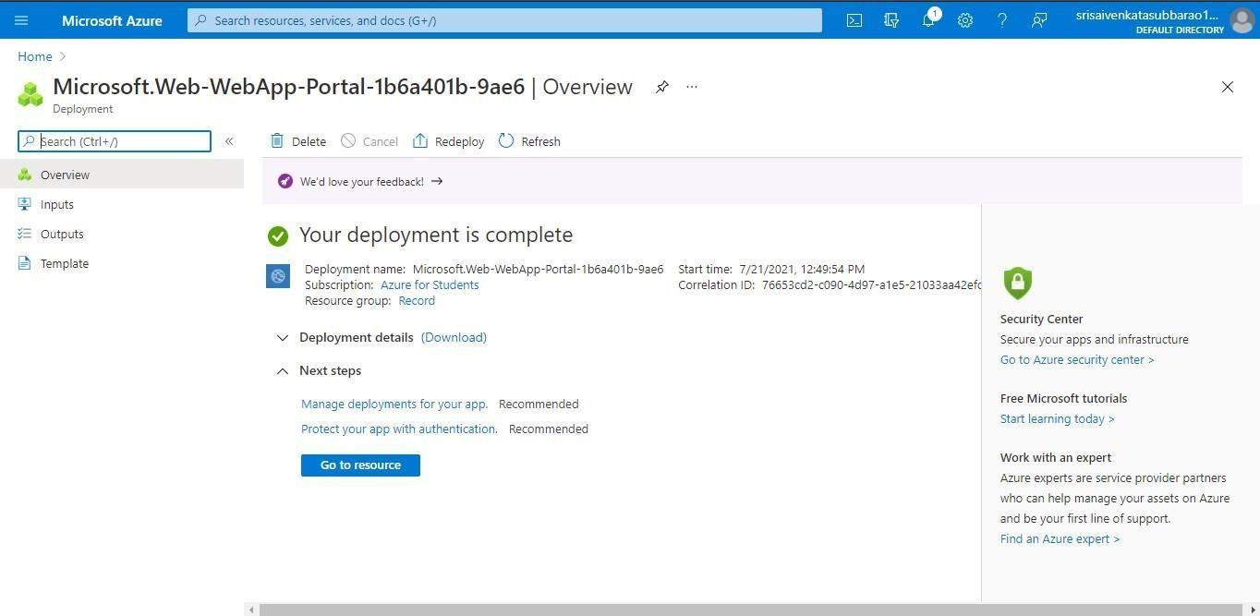

**STEP4: AND OUR DEPLOYMENT**

**IS COMPLETED. STEP5: GOTO WEBSITE URL LINK.**

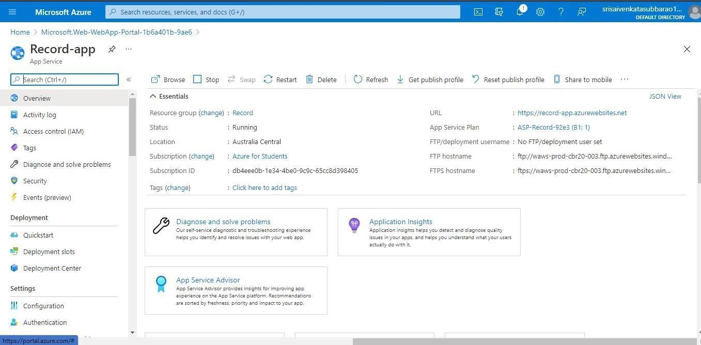

**STEP6: THIS IS OUR WEBAPP SERVICE.**

